Chapter 3, Problem 3.

Find the currents i₁ through i₄ and the voltage v_{o} in the circuit in Fig. 3.52.

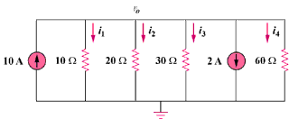
8 A
20A

Figure 3.52
For Prob. 3.3.

